National Central Repository

Standard Operating Procedure:
Document Title | How to submit a National PPPG to the Repository Team
SOP Number | NCR-WCMS-0007
Accessible | HSE National Central Repository
Department | National Central Repository Team / Health Library Ireland
Approved by | Emer Quigley, Project Manager
Date approved | 31/01/2024
Revision | 1

Content on HSE National Central Repository:
The inclusion criteria for the HSE National Central Repository is all approved HSE national policies, procedures, protocols, guidelines (PPPGs) and clinical guidelines. The Repository is the single trusted source for accessing, storing and management of all such documents.

Procedure:
- Document Owners should note all new and revised HSE national policies, procedures, protocols, guidelines or clinical guidelines, should use and follow the headings in the current National Template, which should always be accessed on the home page of the HSE National Central Repository. https://www2.healthservice.hse.ie/organisation/national-pppgs/

- You must use and follow the headings in the National Template available to download on the Repository. Of note, cover pages 2+3 of the National Template are required for strict document control, clear document ownership and meeting the publishing guidelines for the content management system of the Repository. See Figure 1.

- The Repository Team are responsible for the following administrative tasks:
  - The current National Template and headings have been used and followed.
  - The cover pages of the National Template have been completed and are correct, such as the version number, document title, review date etc.

- The Repository Team are not responsible for reviewing any content for accuracy (such as typo’s) or formatting within the document.

- The final approved HSE National PPPG should be saved in PDF format and emailed to the Repository Team at ncr.team@hse.ie

- Once your HSE National PPPG is uploaded to the Repository, a confirmation email with the url link to the document on the Repository, will be emailed to the generic email address of the Document Owner.

If you manage your own content on your HSE webpage:
- If you wish to list your HSE National PPPG on your website, you can do this as normal once your PPPG has been uploaded to the HSE National Central Repository.
- Document Owners should then request their webpage content editor to create a link on their page to the location of their document on the HSE National Central Repository i.e. the link to the document will be the url link provided to you by the Repository Team.

If HSE Digital manage your content on your HSE webpage:
- If you wish to list your HSE National PPPG on your website, you can do this as normal by emailing your request to digital@hse.ie and including the url link to your document on the Repository provided to you by the Repository Team.

NB: Document Control
- It is crucial that copies of a National PPPG are not uploaded to different electronic locations.
- Only the url link to the document on the Repository should be used in other electronic locations. If anything is changed on the Repository, the url link will automatically update on these other locations.
- If you are replacing an existing document on the Repository with a new version, the url link remains the same and no further action is required in relation to updating your own HSE webpage or other electronic locations you have placed the link on.

Figure 1: Published Policy on the HSE National Central Repository

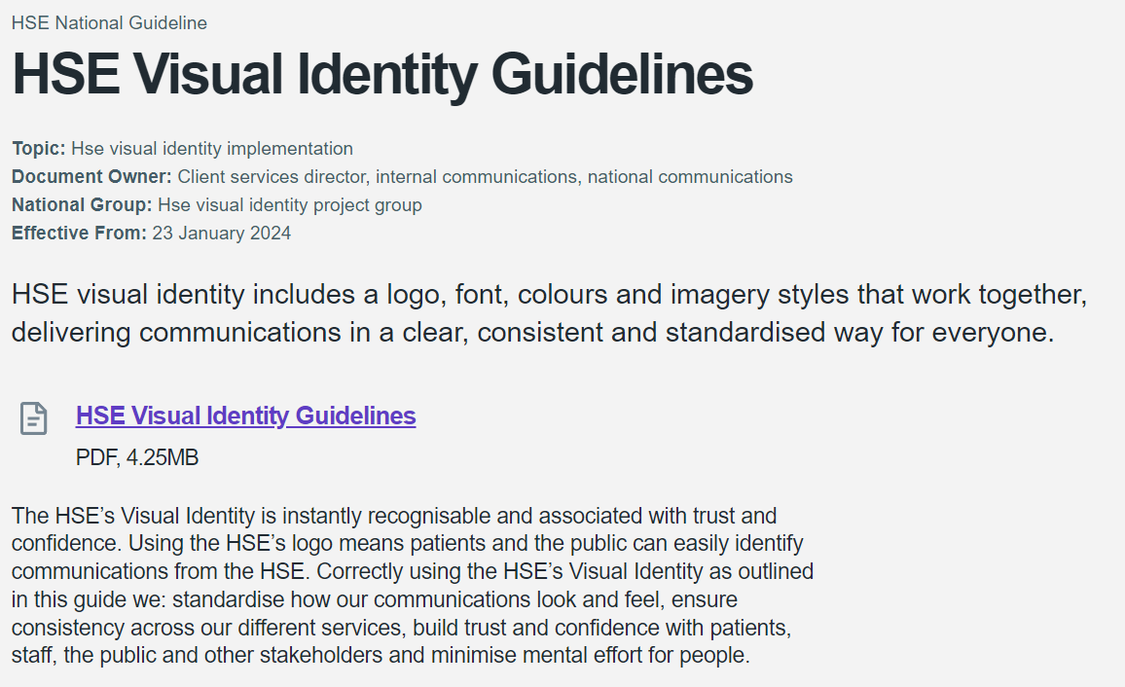

If you have a query for the HSE National Central Repository Team, please email us at ncr.team@hse.ie

