National Central Repository Standard Operating Procedure:

Naming and publishing documents on the Repository
Document Title | Naming and publishing documents on the Repository
SOP Number | NCR-WCMS-0006
Accessible | Resources section on HSE National Central Repository  https://www2.healthservice.hse.ie/organisation/national-pppgs/?category=2
Department | Repository Team / HSE Health Library Ireland
Approved by | Emer Quigley, Project Manager
Last updated | 02/12/2023
Revision | 1

- The inclusion criteria for the HSE National Central Repository is all approved HSE national policies, procedures, protocols, guidelines (PPPGs) and clinical guidelines.
- The title of these documents should be short but meaningful such as ‘HSE Policy and Guidance on Lone Working’.
- All HSE National PPPGs and Clinical Guidelines on the Repository should be consistent in their naming format and align with the five categories of documents stored on the Repository.
- The title of every document on the Repository should begin with one of the five categories listed below. This is indicated on the National Template (cover page) which is accessible to download from the Repository. https://www2.healthservice.hse.ie/organisation/national-pppgs/
  - HSE National Policy
  - HSE National Procedure
  - HSE National Protocol
  - HSE National Guideline
  - HSE National Clinical Guideline

- The title given to the document will be published at the top of the page on the Repository and will be the title on Google or internal search results.
- The ideal number of characters is 65, so the published title on the Repository may be shortened to aid reading on mobile devices.
- The publication information (figure 1) is required on the National Template including; title, topic, national group, short summary and description. In line with Repository document content management system guidelines, the information provided will determine how your document is published on the Repository (figure 2). Completing all the required fields of information will ensure your document is quickly and easily identifiable and published correctly on the Repository.

Figure 1: example of publication information on the National Template

PUBLICATION INFORMATION
These details are required for the content management system on the HSE National Central Repository and are published with the document.
Title:
This will appear at the top of the page and will be the title on Google or internal search results.
Ideal is 65 characters, so published title on the Repository may be shortened to aid reading on mobile devices.
Example:
HSE Policy and Guidance on Lone Working
Topic:
Add one topic tag only.
Lone Working
National Group:
Identifies the group that developed the document.
National Health & Safety Function (policy team)
Short summary:
Ideal is 160 characters. This should very briefly summarise the document, building on the words included in your title. This summary will also be visible as the description on Google or internal search results and on pages where the publication may be listed.
It is the policy of the HSE to ensure the safety of lone workers by minimising the related risk and putting in place appropriate measures to improve their safety.
Description:
Max 500 characters. This can be longer than the short summary but should still be short. Focus on the key points you want someone to know about this publication.
The purpose of this policy is to raise awareness of the risks presented by lone working to managers and employees. To provide a framework to support managers in managing lone working activities in consultation with their employees. To provide evidence based guidance on minimising the risk associated with lone working activities. To outline the responsibilities each employee has in relation to their role as a lone worker.

Figure 2: published Policy on the HSE National Central Repository.

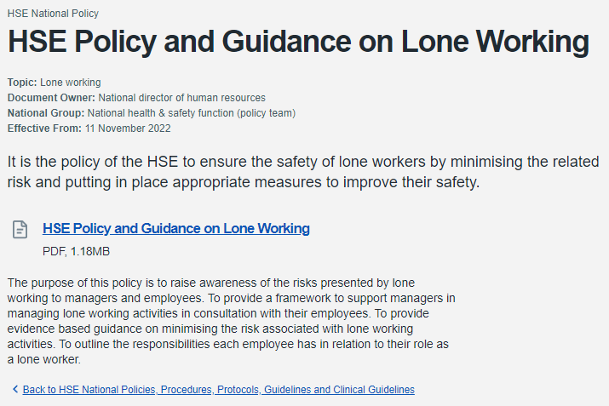

https://www2.healthservice.hse.ie/organisation/national-pppgs/hse-policy-and-guidance-on-lone-working-2022/

If you have a query for the HSE National Central Repository Team, you can contact us at ncr.team@hse.ie

Details the document information required for publication on the HSE National Central Repository.

